**CS5590VC Lab HW1**

**Jian Wang**

**08/28/2013**

1. create a ScrumDo account following the tutorial 1
2. Registering account and Creating stories

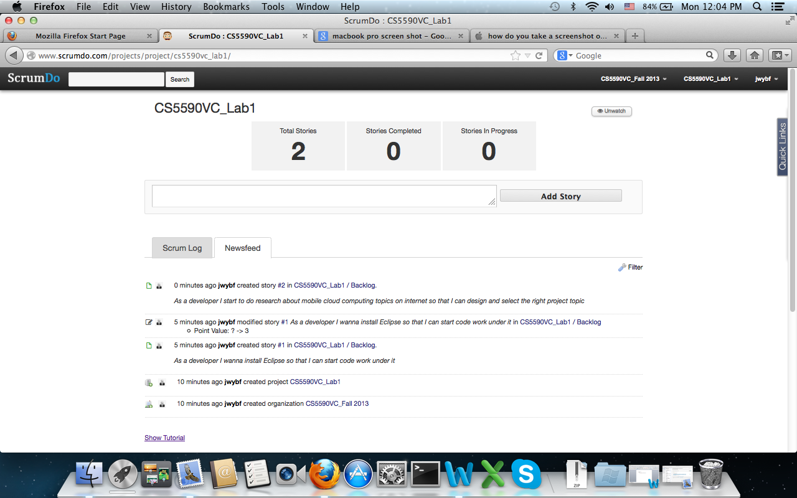

b. Creating Iterations:

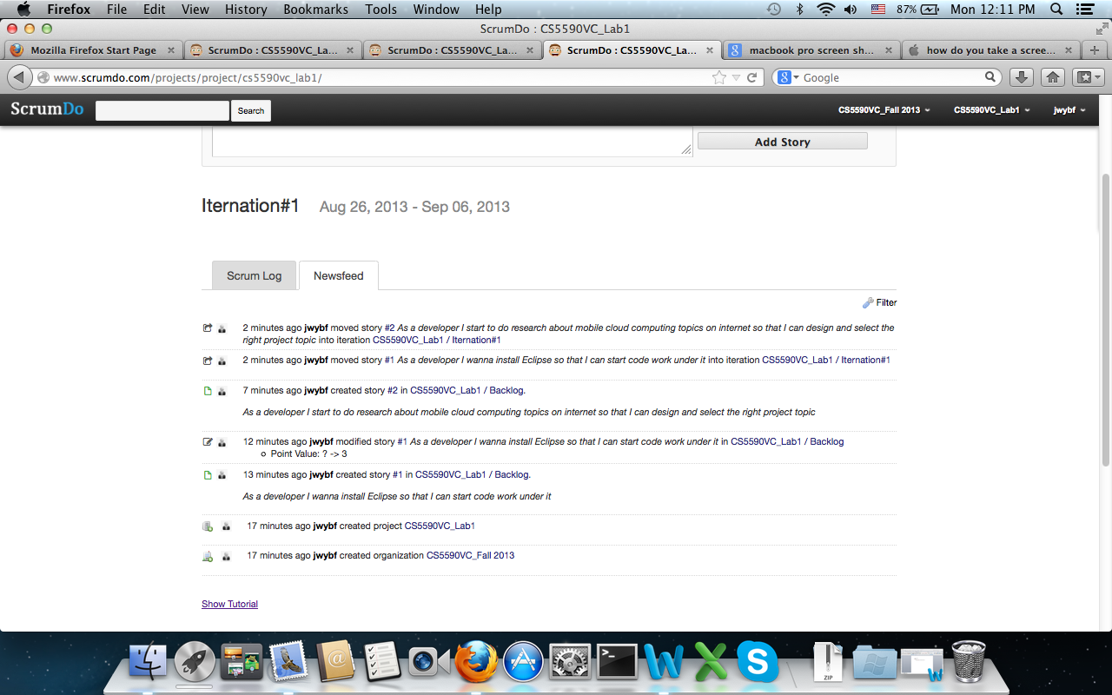

1. Creating epic stories

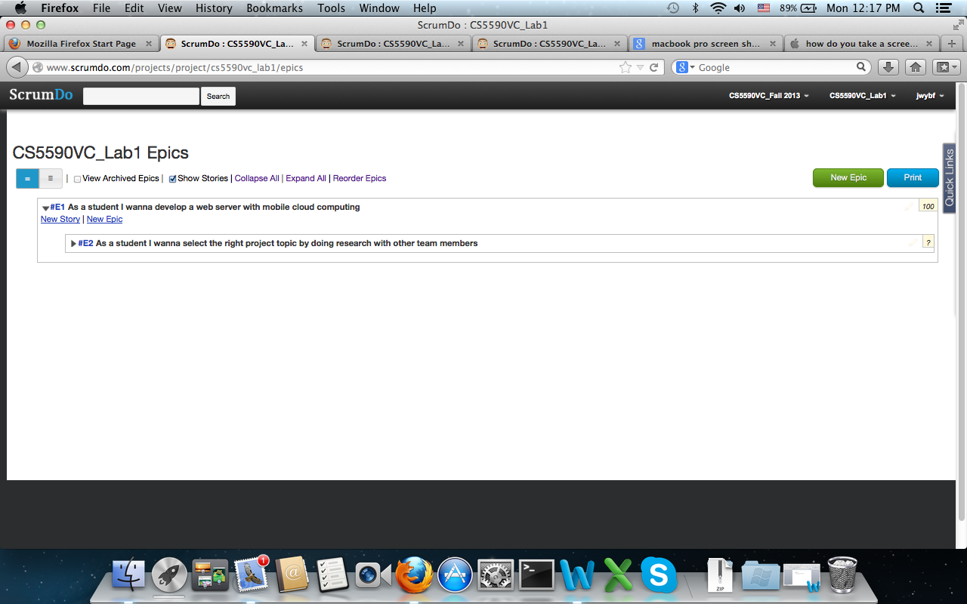

1. Scrum board:

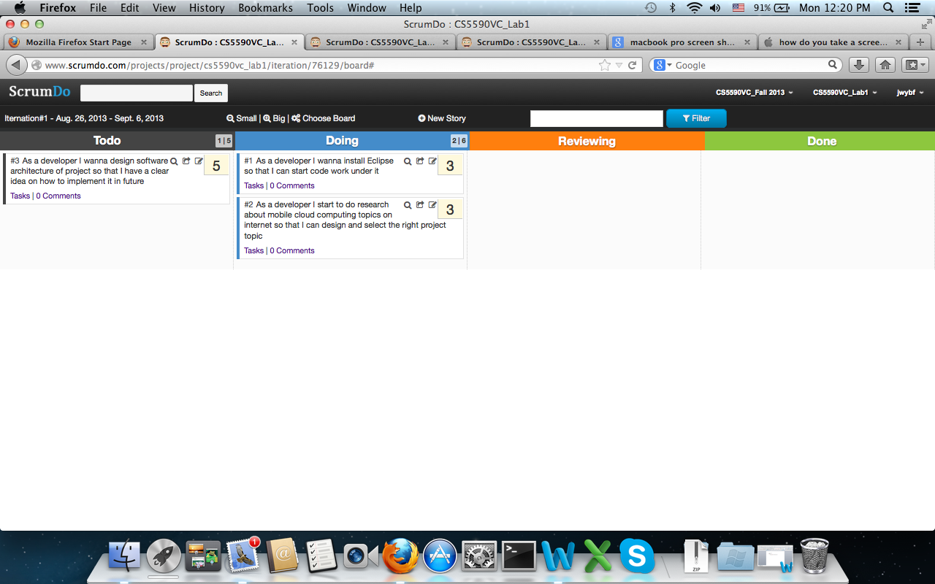

1. Adding account access for all team members:

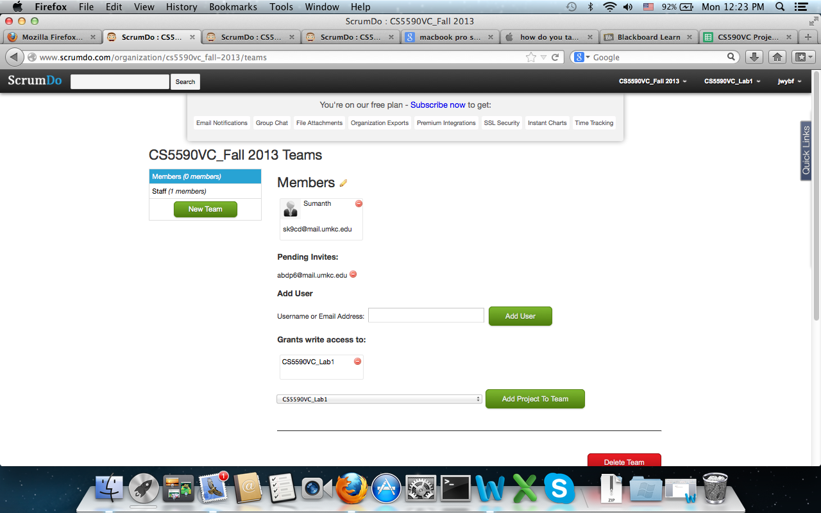

1. GitHub Account:

a. Creating Github Account and Clone one folder CS550VCLab1

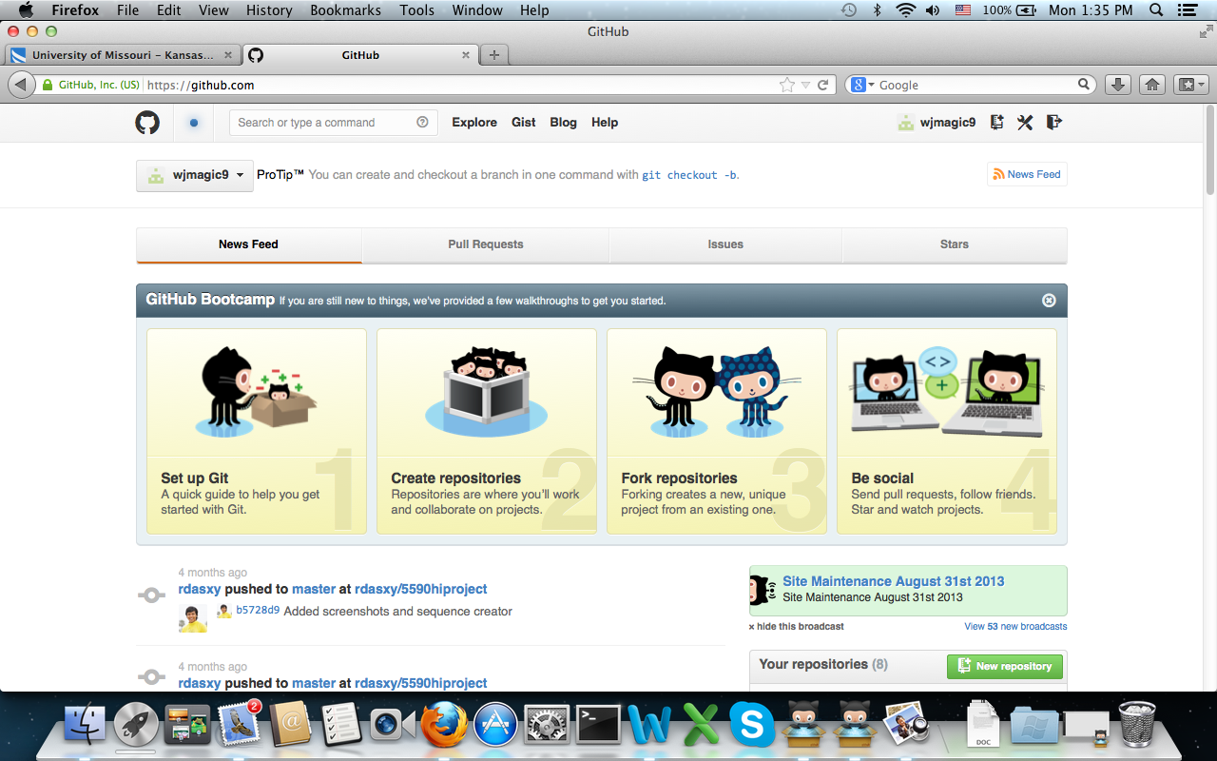

1. creating file [CS5590VC Lab HW1.docx](https://github.com/wjmagic9/CS5590VCLab1/blob/master/CS5590VC%20Lab%20HW1.docx) in the folder and push it to my github account.

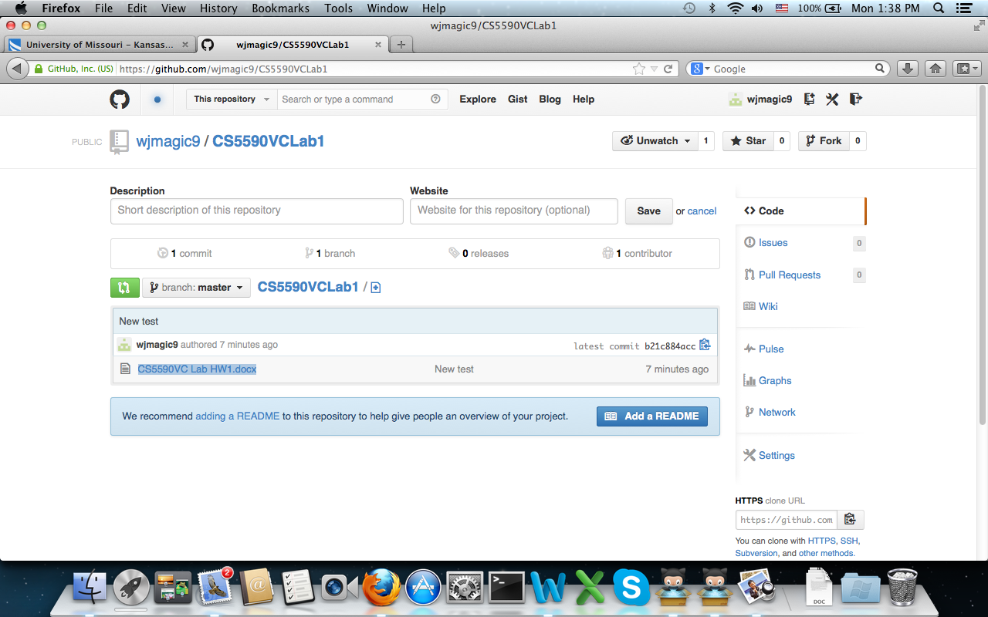

# creating another user [[https://1.gravatar.com/avatar/614a48978793e1f2a6e2d6cf33a7a253?d=https%3A%2F%2Fidenticons.github.com%2Ff0dd54229a26269e9a1f5335735c92b5.png&s=140](https://github.com/CS5590VCteammember2)CS5590VCteammember2](https://github.com/CS5590VCteammember2) under Team organization [UMKCCS5590VCJianWang](https://github.com/UMKCCS5590VCJianWang)

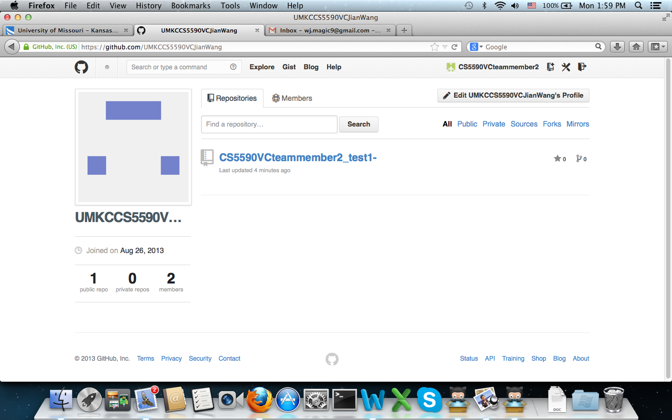

### d. Clone project CS5590VCteammember2_test1 to local computer

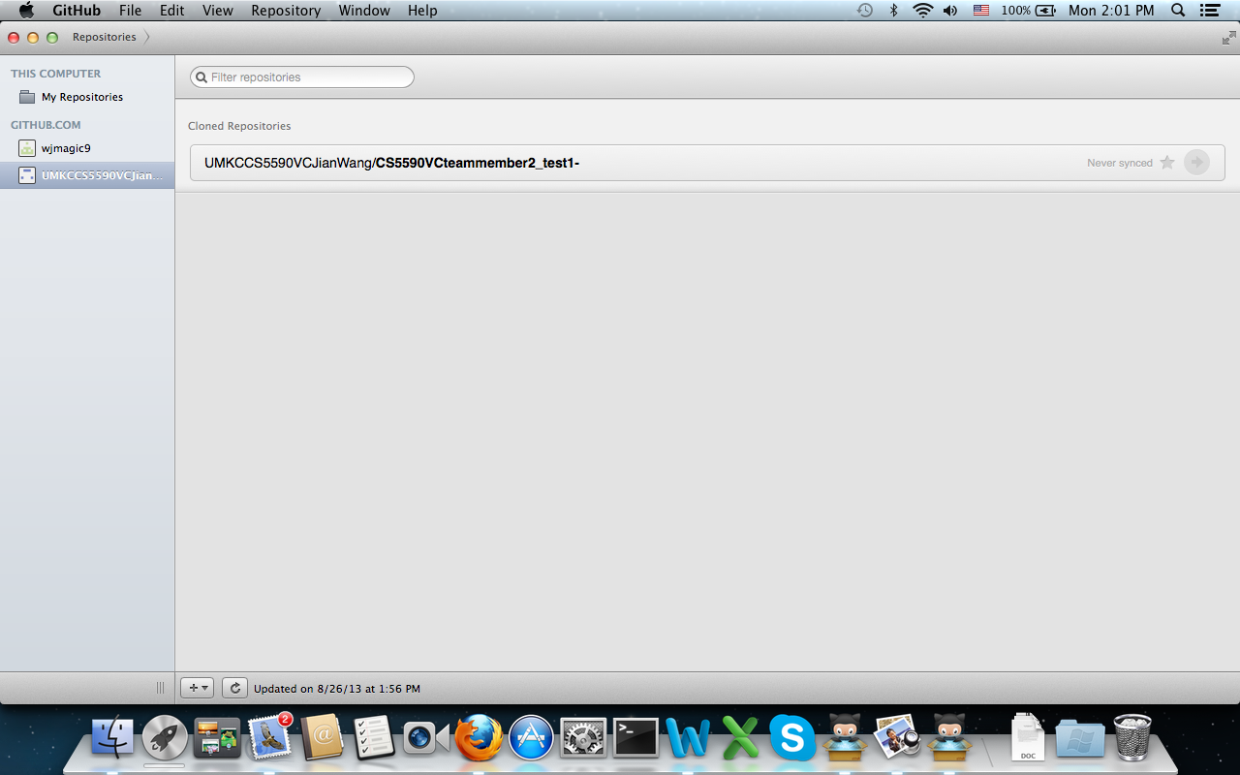

1. Adding a file and push it to remote repository.

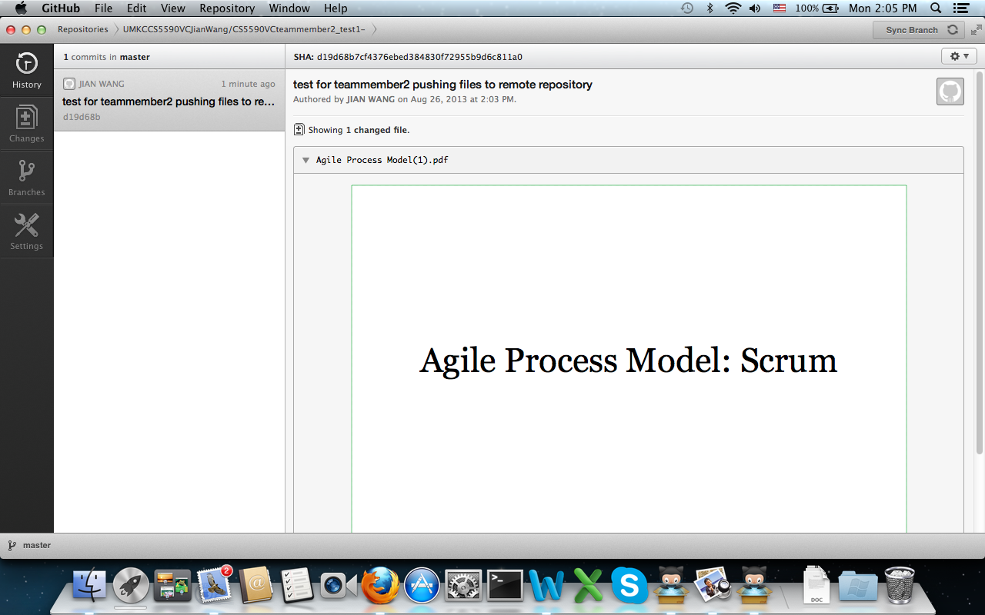

Check the remote side:

